- Lets freeze the top part as High end did:
This is how it is now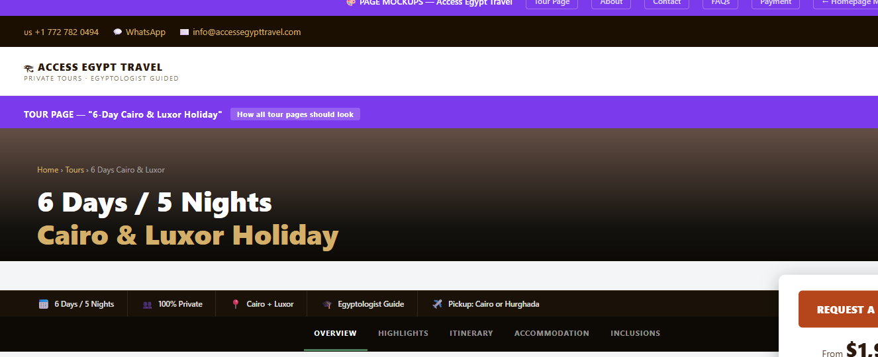
Lets change it to 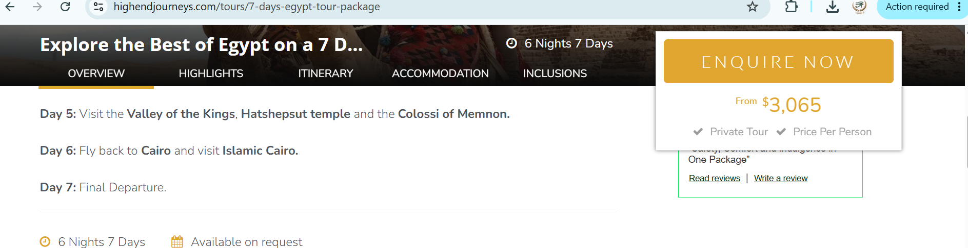
- Background should be moving picture of main attraction. Maybe we can use 10 pictures as Memphis tours did. If storage or size of the website an issue we can increase and upgrade
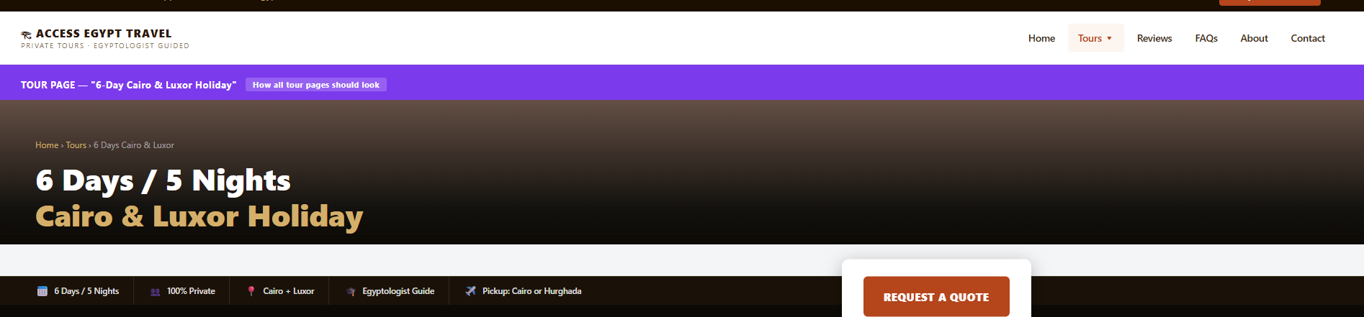
- Can we use this wording similar to high end” Explore the Best of Egypt on a 6 Days Egypt Tour Package” it sexy.
- For the pop ups we can move the temperature if it frees some space for pictures.
- Highlights and sites to be updated at a later stage to open a new page.
- Very sexy 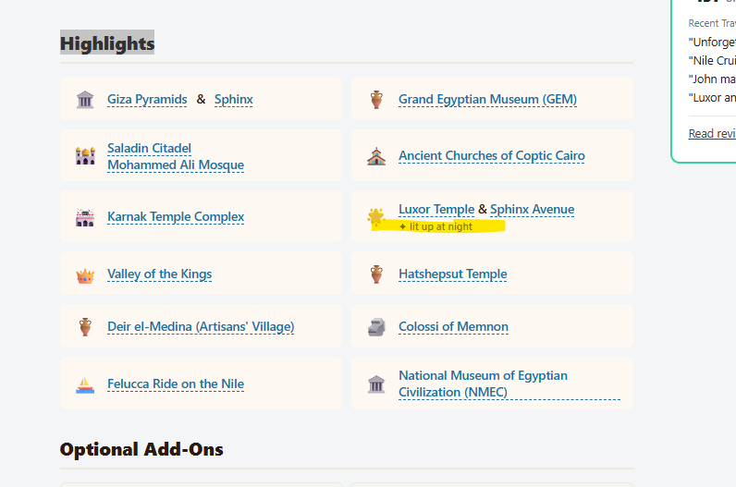
- Lets remove this and John will word it differently in the overview. 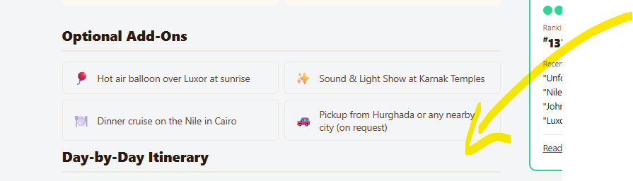
- Very nice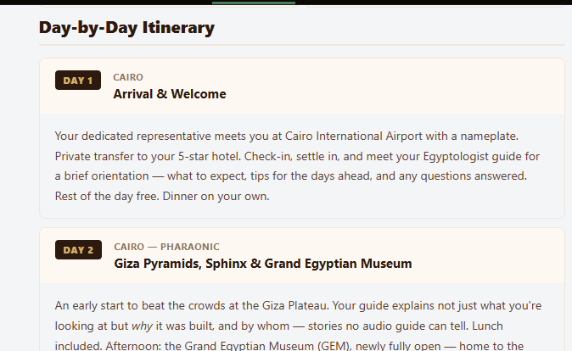
- This is included 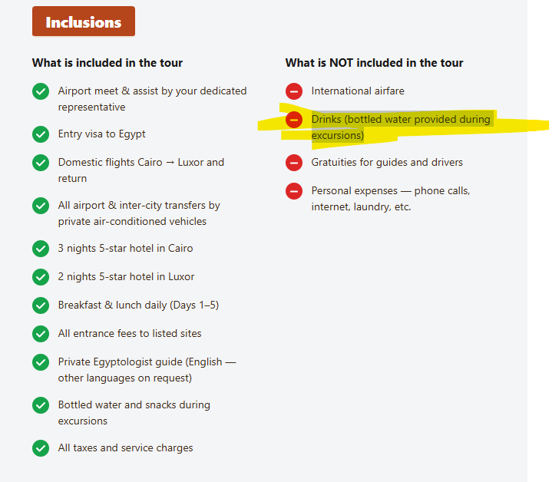
- Add travel insurance under exclusion
- I’m not a big fan of list an increase on the top, should we move it down? What you think? 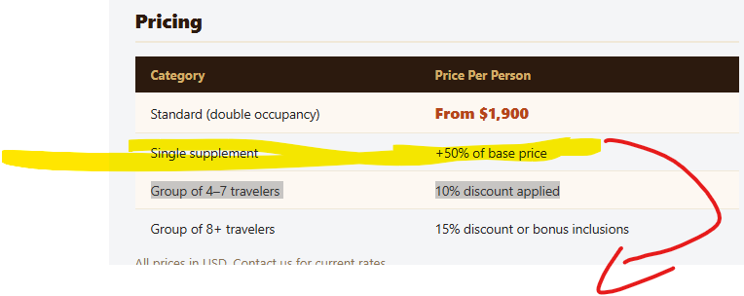
- Under about us, John will add 3 other guides and we should add me as CFO and you as CTO

